Ocean Shores
Friends of the Library
Winter 2021 Newsletter
The FRIENDS OF THE LIBRARY [FOL] is an independent group dedicated to providing support and advocacy for our library.

Message from the President
Ocean Shores Friends of the Library Members,

Wow, this year seems to have flown. I'm hoping that everyone had a peaceful holiday season. Are you ready for 2022? If you haven't stopped at the library this is a great time of year to take it easy and catch up on your reading! I'm reading "Brain Rules" and "Brain Rules for Aging Well" by John Medina. They are easy and fascinating reading with information about how our brains work and how to improve. There is a science-based reason you and your siblings remember childhood events differently! I highly recommend both of these books. Stay well and hopefully we will be able to see each other in the new year.
-Malinda

FOL Officers
President – Malinda Griffin Member at Large (2 yr) – Judy Gow
Vice President – Pam Clark Member at Large (2 yr) – Sharon Coone
Treasurer – Diane Durbin Member at Large (1 yr) – Kathy Baker
Secretary – PJ Ford Slack

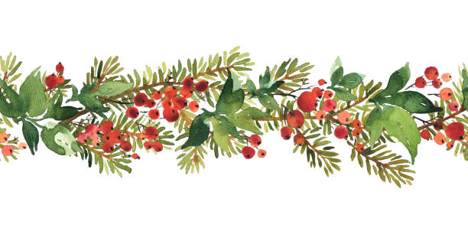
From Friends to Friends

NEW YEAR, NEW TREASURER
It has been my pleasure to serve as the FOL Treasurer for the last few years. It has been exciting to see the membership grow and community support increase. During the month of January my duties will transition to Diane Durbin and FOL Finances will be in good hands.

Your Executive Board for 2022 includes:
President, Malinda Griffin
Vice President, Pam Clarke
Secretary, PJ Ford-Slack
Treasurer, Diane Durbin
Members at Large, Judy Gow, Sharon Coone, and Kathy Baker

Other Committee Chairpersons
Volunteers, Sylvia Schroll
Membership, Malinda Griffin
Newsletter, Kathy Baker
Bookstore, Mary Jo Lohrenz
Booksale, VACANT

THANK YOU ALL for being part of Ocean Shores Friends of the Library.
Mary Jo Conibear-Lohrenz
**************************************************
DONATION DAYS
To avoid NFL Playoff Games, Donation days have been moved to Monday for January and February. Mark your calendars for January 17th and February 21st, Noon - 2 PM. Donations welcome include Books (Fiction, Non-Fiction, Adult, Children’s), DVD's (One of our hottest sellers), Audio Books, Puzzles, and Educational Games. All items must be free of odors, mold and mildew. Thank you for the continued support of the FOL Book Store

AMAZON SMILE
When ordering items from Amazon please be sure to use AmazonSmile and select Ocean Shores Friends of the Library to receive a donation. Every little bit helps. THANK YOU.

BOOK STORE HOURS
Remember the Library Meeting Room Book Store is open the same hours as the library, Tuesday - Saturday 11 am - 5 pm and Sunday Noon - 4 pm. Customers are welcome to shop as long as there is not a meeting scheduled in the room. Suggested prices for most books, games, and puzzles are 2 for $1. DVD's $1 each, and occasionally you will find some specially priced items. Your purchases help fund all the Special Programs offered at our amazing library.

BOOK SALE UPDATE
Book sales will continue to be suspended until it is safe for all of our volunteers and patrons. Let's hope the Covid exposure threat continues to decrease.

FOL Year-to Date Financial Report –Mary Jo Lohrenz
1 January – 30 November 2021

INCOME
Book Bags 204.00
Copy Machine 276.00
Donation 6307.13
Honesty Box Sales 4294.61
Membership 860.00
Amazon Smile Donation 112.32
World of Books 643.49
______________________________
TOTAL INCOME 12672.55

EXPENSES
Bookstore supplies 47.93
Coastal Mowing 326.40
Copy Machine 76.64
Insurance 1776.00
Library Programs 1500.00
Membership Brochures 116.38
PO Box Rental 64.00
SOS License 10.00
______________________________
TOTAL EXPENSE 4178.53

Account balances as of 30 November 2021
--Checking Account 5,033.33
--Savings Account 17,581.82
--CD 25,689.43 (renewed 5 May 2021)

Did You Know
Carnegie funded several New York City libraries, and those buildings were often constructed with apartments on the top floor. The idea was that the library’s custodians would have living quarters so that they could keep shoveling coal into furnaces at all hours of the day and night.

Library Services

Ocean Shores Heritage
Explore the history of Ocean Shores online at www.washingtonruralheritage.org see photographs and listen to interviews all about the history of Ocean Shores.

Book a Techie
Schedule your half an hour session over the phone or in person and get answers to your burning questions or solutions to your problems. Techie cannot help with hardware issues.
Register one week in advance
Current Ocean Shores Library Card required

Newsbank
Read the Seattle Times and other newspapers in full-text with images online with your library card.

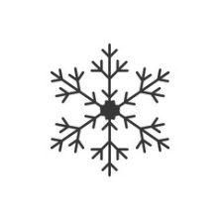
WiFi
WiFi is available
6:00am–10:00pm at the Ocean Shores Library
No password needed
Users must agree to Terms of Use

Library Meeting Rooms
The Library has two meeting rooms available for the public to use.

Blu-ray Player Checkout
Portable 10” Blu-ray player available for checkout

Display Case
Do you have a collection that you would like to share with the community? Does your organization want to do a display? The lobby display has openings in 2022.
Lobby Displays/Jan-March 2022
January 2022: Funko collection, Niko Laranang
February 2022: Vintage and Antique Valentines, Elly Smith
March 2022: Garden by Sea

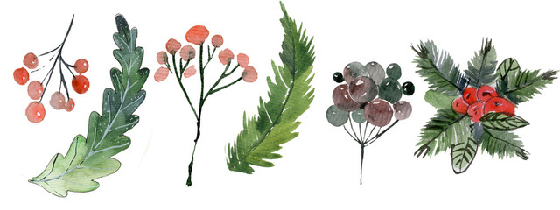
Art in the Library Exhibit
January 2022 Terry Visser
Animals, scenery and abstracts featuring a blend of acrylics and oils. Frames are a variety of different woods with unique grains and colors of stains.
February 2022 Harley Price
Acrylics/Watercolor – Retro, bold, colorful and imaginative
March 2022 Corrine Holden
Corinne is a fiber artist, who seeks to use fabrics that she can reuse, repurpose, or recycle. Her creations range in size from hand held items to large wall hangings.

Children’s Programs
January – March 2022
Story Time Saturday mornings 10:30-11:00 am
Books rhymes, songs, interactive stories, and FUN! Ages birth-5. Presented by Niko
Kid’ Craft Adventures All month long
Elementary children/parents can pick up a craft kit at the library during open hours. Inside will be a fun craft and a themed activity booklet based upon a children’s book series. Each month will be a different theme.

January theme: Big Nate Book Series Craft Kit: Robot Mask
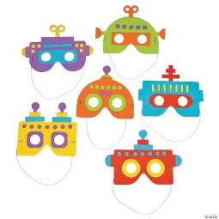
February theme: Diary of a Wimpy Kid Craft Kit: Mosaic Crown
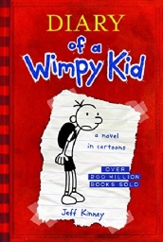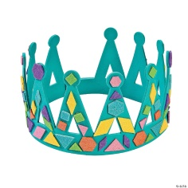

March theme: Dr. Seuss Craft Kit: Dr. Seuss Fishbowl
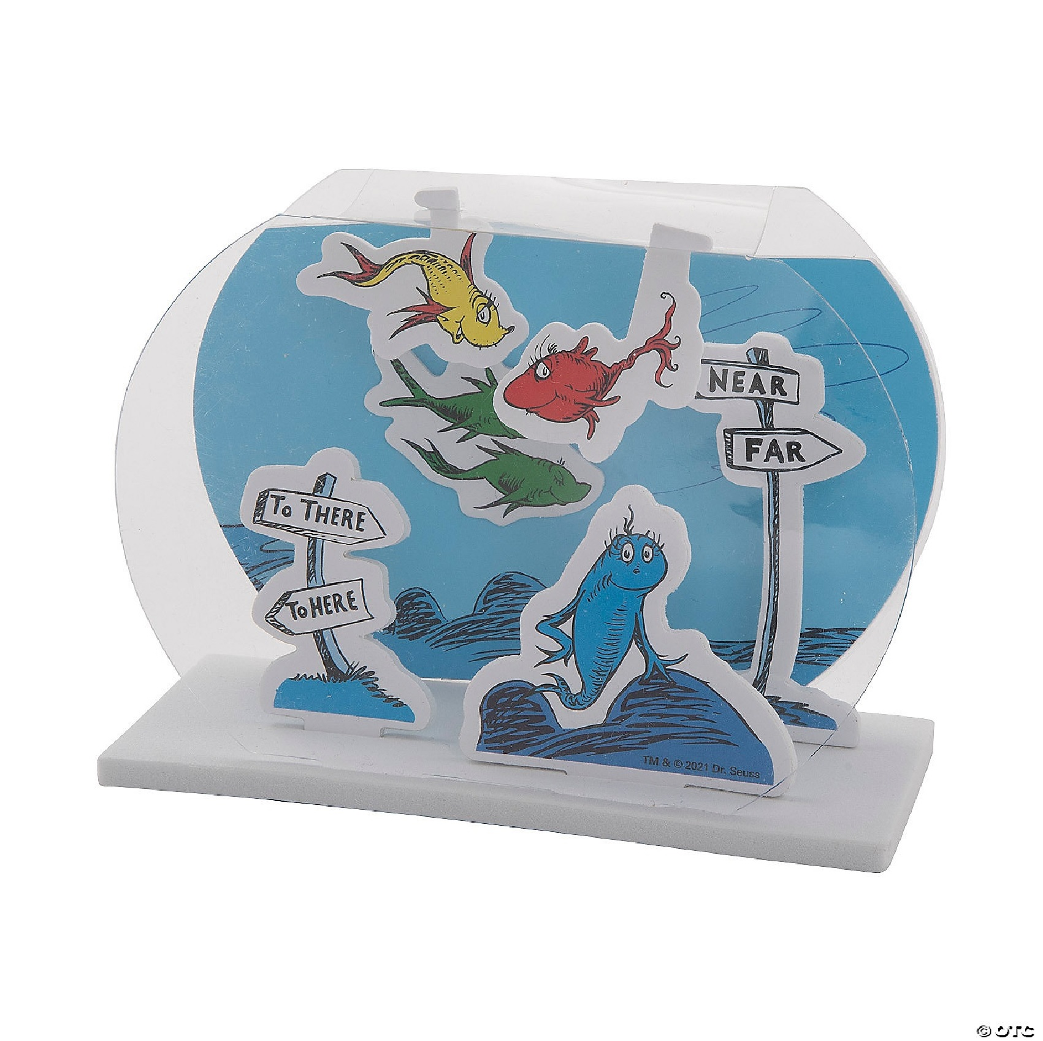
March theme: Dr. Seuss Craft Kit: Dr. Seuss Fishbowl:

Teen Activities

The Teen Advisory Board started meeting in October of 2021 again. We currently have 4 members and are hoping to increase participation after the new year. We are planning our first big Spring Teen Event in March (stay tuned for a date), an After Hours Teen Takeover. Teens will sing karaoke, play video games on the meeting room projector and enjoy delicious food. This will be the first large teen event since October of 2019, and we are excited to get back to in person programming for teens.

The Teen Advisory Board meets the 3rd Saturday of each month at 3:00pm.
Local teen’s grades 6 – 12 are invited to assist staff with teen events and selecting teen materials.
TAB Meetings/January-March 2022
- Saturday, January 22nd
- Saturday, February 26
- Saturday, March 19

Library Outreach
Michelle Traer started going back to the North Beach Middle/High School in September and offering a mobile library to the students. Every Thursday during lunches she brings books the students have on reserve, issues library cards, and has a selection of materials available to check out. Students can also return Ocean Shores Library materials to her. This program has been active since 2013 and is a great way to reach our Middle/High school patrons and help them become public library users.

Adult Library Programs
BOOK GROUP
- Book Group meets on the 3rd Friday at 3:00pm
- Ocean Shores Friends of the Library sponsors this program and purchases 10 copies of each title to be checked out for 2 weeks.
A big thank you to the Friends of the Library for sponsoring this program since January of 2012! The Book Group has enjoyed reading the books the Friends of the Library purchase each month. The Book Group went back to meeting in person in July of 2021 after a time on Zoom and it is so nice to see everyone in the library meeting room. If you would like to be added to the Book Group email list, contact Michelle Traer at mtraer@osgov.com
January 21 Single Thread by Tracy Chevalier
February 18 Nickel Boys by Colson Whitehead
March 18 Numbers Don’t Lie by Vaclav Smil

Houseplants 101
February 5 Saturday 1:00pm-3:00pm
Introduction to the basics of houseplants: soil water, light and temperature, transplanting, propagation and pests. You’ll go home with informational handouts including plenty of additional resources. You may even have a new plant to take home with you. There will be plenty of time for one-on-one conversations and questions following the presentation.
Presented by Garden by the Sea.

Estate Planning
March 23 Wednesday 1:00pm–3:00pm
TwinStar Credit Union staff will present this vital information.

Free
Tax Assistance from the AARP
Begins Tuesday, February 1st 10am-2pm
Every Tuesday and Thursday from 10 am-2 pm in the Library Meeting Room through April 14
Appointments are required. Scheduling information will be available mid-January.
This is for basic individual tax preparation, no business tax help.
For tax forms and additional help…www.irs.gov

From the Board of Trustees
Thank you, Friends of the Library, for your support of library programs over the past year. The funds from your meeting room book sales have been critical for monthly children’s crafts, children’s programs, and adult book club. The 5-member governing Board of Trustees continues with stable membership through 2022. Each board member serves a five-year term with an optional five-year appointment. The officers serve a one-year term elected each January.
The Board’s first task in the new year is to review the 2020-2025 Strategic Plan. The strategic vision, the aspiration, is: “The Ocean Shores Public Library will be the essential community resource for residents to access information and ideas that strengthen and enrich their lives.” The strategic mission is: “As the heart of the Ocean Shores community, the library provides access to the world through reading, learning, and connecting. “
The vision and mission will continue to guide the library as the Board examines the specifics under the Strategic Plan to keep services relevant to the community.

Denise Siers, President

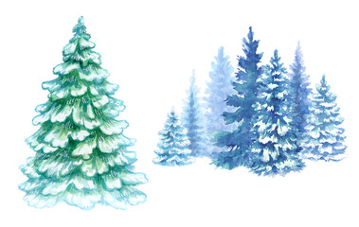

“If you don’t like to read, you haven’t found the right book.” – J.K. Rowling

Book Notes

Christmas Days: 12 stories and 12 feasts by Jeannette Winterson.

I can start to read one story and one recipe about mincemeat. My great grandmother would make mincemeat tarts for the holidays but you had to start the mincemeat right after Halloween. Reading the story and recipe then gets me ready for the holidays. I love it.

I use The Snow Mama story with 2nd and 3rd graders. It is amazing to hear what they kids focus on and then they create snow people or snow cats or snow fish out of paper and cotton and ribbons. The bulletin board is always great. There is sadness in this story and the kids I teach understand Jerry and not having a Christmas.

Short stories are not my thing but this book of short stories grabbed
me from the first reading. Every year, whether I read or listen to this book on audible I am grabbed anew by Winterson's stories. My spirit is transported to different places, I imagine the taste of each recipe and love the narrative of how she chose them or the people attached to the taste.

I dare anyone, lover of the Christmas season or not, to not be moved by one of the stories, The Mistletoe Bride, The Lion, The Donkey and Unicorn....and they got in. 12 stories to delight and savor.

Enjoy...pj ford

The Long Winter by Laura Ingalls Wilder
Although this is not a book aimed at adults, I have always enjoyed reading about how the pioneers dealt with adverse conditions, and the long, brutal winter described in this story by plucky young Laura describes a winter I would hate to endure, even now. This story, with its characters’ observations of nature pointing to the coming weather and their use of what was at hand to get ready for the coming season illustrate a resilience and ability that we have largely forgotten.
Reading this story absolutely creates a feeling of gratitude in me for not only the milder weather we generally experience here, but the modern technology that forecasts weather for us and allows us to live so, so much more comfortably than in days past. I think perhaps that appreciation for what we now have is a large part of my enjoyment.
Kathy Baker

Here’s for all of our armchair travelers – real travelers, too. This looks like somewhere I would definitely like to go! How about you?

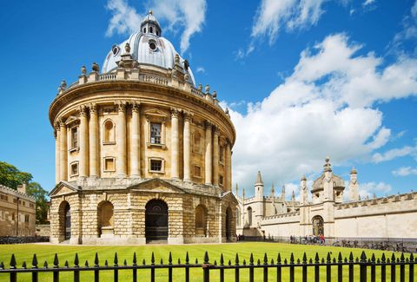
Oxford University’s Bodleian Library is one of the most celebrated in Europe with the Magna Carta and Shakespeare’s First Folio amongst the institution’s 13 million printed items. One of the most recognizable buildings apart of the library group, the masterful Radcliffe Camera, designed by James Gibbs, is the earliest example of a circular library in England. The neoclassical structure has gain popularity in mainstream culture after being feature in films such as Young Sherlock Holmes and The Golden Compass.
Note from the Editor
So much has happened this year, in the world, in our country, and in our town. Some things are better, some are worse, some are just different, and the future is still uncertain in many ways – not quite what we had all hoped for. I read a comment about the state of things (from some non-famous person) that made a lot of sense to me, “We’re all in the same boat, so grab an oar and just get going”. Trite maybe, but maybe if we all just grab an oar, work together and stay positive, then we can get somewhere better than where we are now. It’s worth a try. Wishing everyone a wonderful year ahead and many good books to read!
Kathy Baker

